# Seasonal Typical Assemblages

In addition to the spatially defined typical assemblages, we derived seasonal typical assemblages for a subset of river types. The four seasons were defined as follows: spring is March to May, Summer is June to August, Fall is September to November, and Winter is December to February.

# Selection of river types

To avoid strong spatial signals in the seasonal typical assemblages (sTA) only those river types (RT) were considered in which samples were evenly distributed between seasons. In most cases, an even spatio-temporal distribution could only be achieved by omitting parts of the data (e.g. certain seasons or data sets). The maps for all RT with all available seasons as well as the respective subsets that were used in the further analyses can be found in the GetRealDrive ([Invertebrates](https://drive.google.com/drive/folders/15Dprr4wWVTAMM23SJvNiUlQIywX2kvAf) and [Diatoms](https://drive.google.com/drive/folders/1QFDkLuune-QUvq_ZY6opt_24Ysoq-kig)). As an example, the map for the combined RT 10+11 is shown in Figure 1.

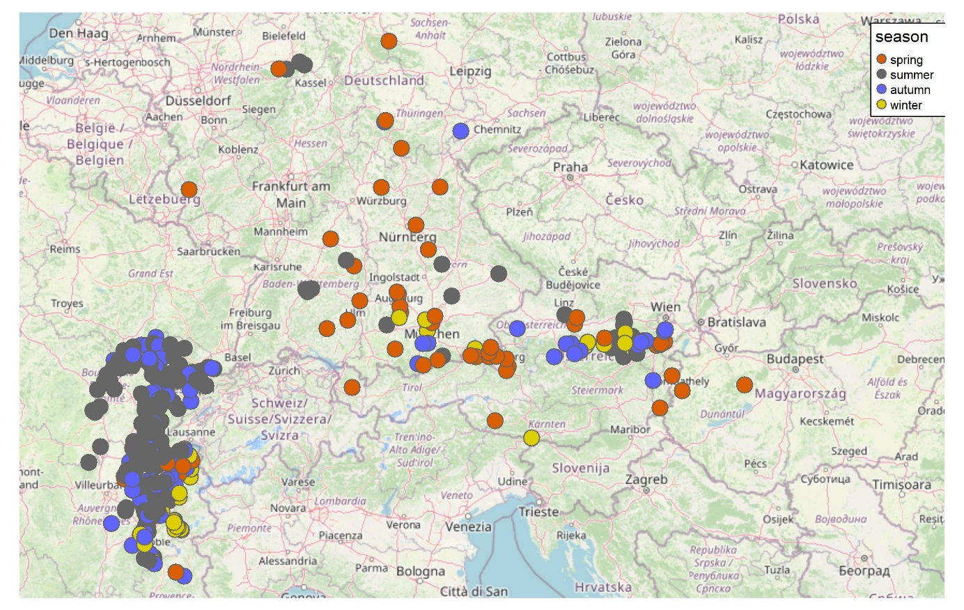

Figure 1: Map of sampling sites for the combines River Type 10 + 11 with information on sampling date. The color of the points shows the season the sample was taken in.

To visualize differences between the seasons we used Nonmetric multidimensional scaling (NMDS) on Jaccard dissimilarity matrices. The resulting NMDS plots are available in the GetRealDrive ([Invertebrates](https://drive.google.com/drive/folders/1SPujT1_bEGAkW4-zu-pzSzSYKn8pVlvg) and [Diatoms](https://drive.google.com/drive/folders/1rWU34tu8lQI_AxVCL6nPOYMqmuuJRo5K)). Figure 2 shows the NMDS plot for invertebrate samples in RT10+11. Further, we evaluated whether the Jaccard dissimilarity between sites would be better explained by spatial distance or by season. To this end, we employed generalized dissimilarity modeling (GDM).

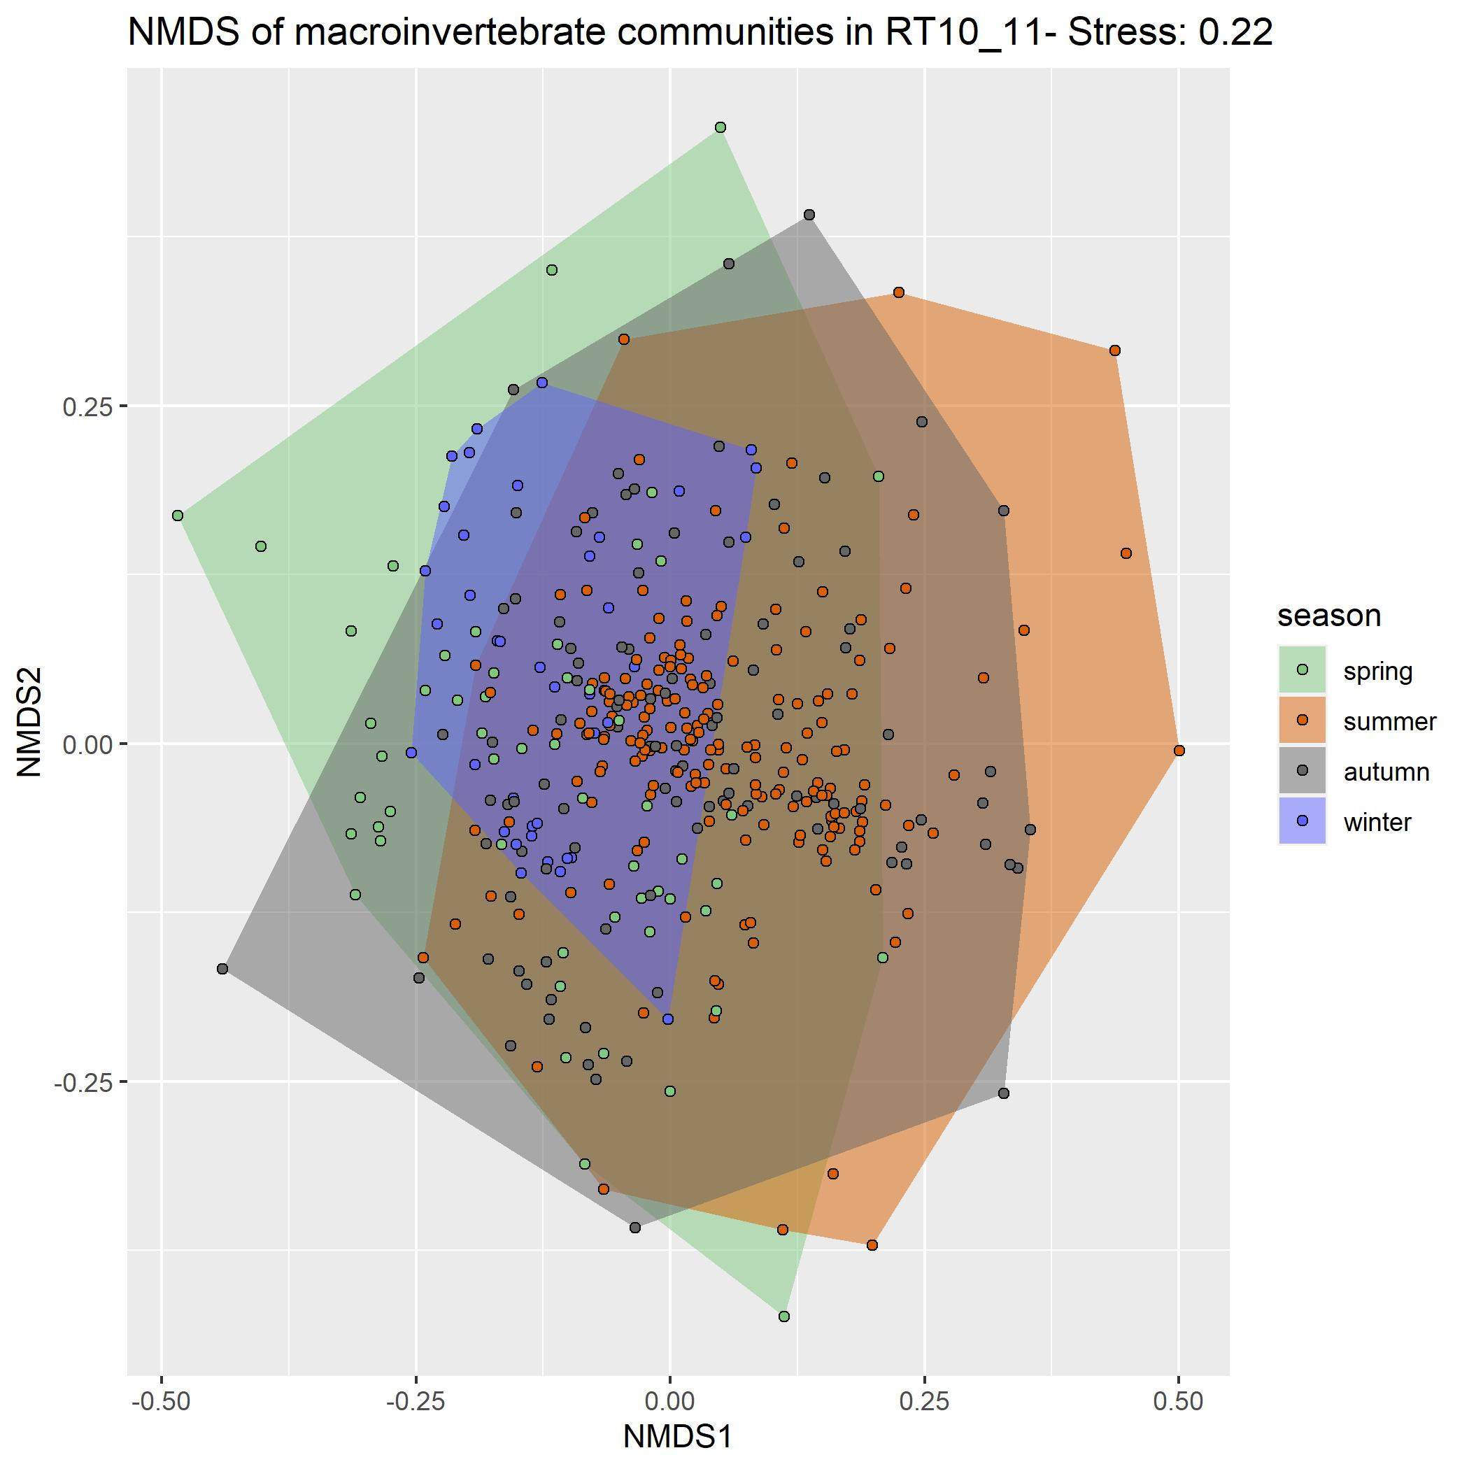

Figure 2: Nonmetric multidimensional scaling plot of Jaccard dissimilarity matrices for macroinvertebrate communities in RT10 + 11. The color of the points shows the season. Convex hulls surround all sampling points from one season.

In GDMs, the response variable is the ecological dissimilarity between two sites (expressed in some a priori chosen dissimilarity metric, here Jaccard). Smooth functions are fitted to the environmental data and the differences between the values of these functions at the two sites of interest are used as explanatory variables. By using a generalized modeling framework we can account for the bounded nature of dissimilarity metrics (between 0-1) and the smooth functions allow for variation in the rate of compositional turnover along gradients. The plots comparing the effect of spatial distance to that of season for all GDMs can be found in the GetRealDrive ([Invertebrates](https://drive.google.com/drive/folders/1aeCYZ5ObqsH_2bJbGQGk3-e50PJwvnfg) and [Diatoms](https://drive.google.com/drive/folders/1oFRRGpwujmBS1AN7tzao-byAqpN-RlY7)), and that for invertebrates in RT10 + 11 is shown in

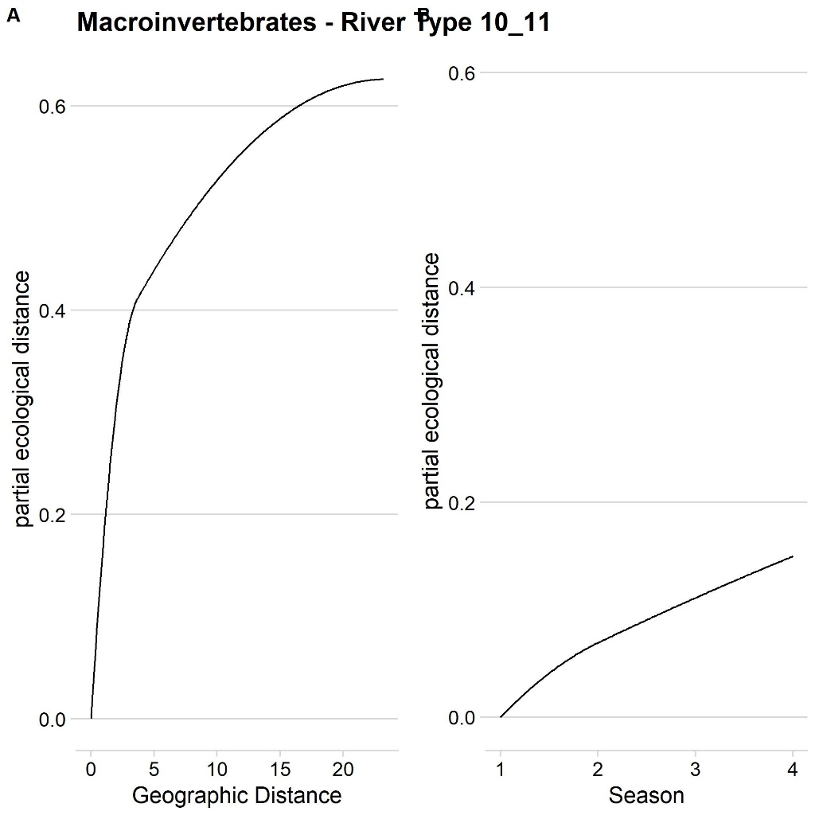

Figure 3: Partial ecological distance between sites with increasing geographic distance (**A**) or chaning season (**B**, 1 = spring, 2 = summer, 3 = summer, and 4 = winter) predicted with Generalized Dissimilarity models.

Based on the results of NMDS and GDMs, we selected RT 10 + 11 and RT 15 + 16 for invertebrates and RT10 and RT15 for diatoms. For these four river types sTA were derived in the same way as the non-seasonal TAs (see prior documents in GetRealDrive).

# Patterns in and overlap between seasonal assemblages

In river type 11, the number of diatom taxa in the sTAs did not vary strongly between the seasons (Table 1). The summer and autumn sTAs were more similar to each other than either of them was to the winter sTA. The latter was most similar to the summer sTA, as they share some *Gomphonema* species (*Gomphonema olivaceum olivaceoides* and *Gomphonema parvulum Complex*) which are absent from the autumn sTA with exception of *Gomphonema pumilum Complex*.

Table 1 Overlap between seasonal typical assemblages (sTA) of diatoms in river type 11 expressed in percent of taxa in row sTA also present in column sTA. The n in the row names shows the number of taxa in the respective sTA.

|  |  |  |  |
| --- | --- | --- | --- |
|  | Summer | Autumn | Winter |
| Summer (n = 28) | 100% | 46.4% | 35.7% |
| Autumn (n = 21) | 61.9% | 100% | 38.1% |
| Winter (n = 22) | 45.5% | 36.4% | 100% |

For diatom in RT 15, the winter sTA is considerably larger than the summer and autumn sTAs.

Both, the summer and the autumn sTAs, overlap 81.2% with the winter sTA. Therefore, they cross the threshold of 75% overlap we used to delineate redundant TAs. The overlap between the winter sTA and either summer or autumn sTA is of a similar size (41.4% and 44.8%). In general, the overlaps in river type 15 are larger than those in river type 11 which might indicate a weaker seasonal turnover in these ecosystems.

Table 2 Overlap between seasonal typical assemblages (sTA) of diatoms in river type 15 expressed in percent of taxa in row sTA also present in column sTA. The n in the row names shows the number of taxa in the respective sTA.

|  |  |  |  |
| --- | --- | --- | --- |
|  | Summer | Autumn | Winter |
| Summer (n = 19) | 100 | 57.9 | 81.2 |
| Autumn (n = 16) | 68.8 | 100 | 81.2 |
| Winter (n = 29) | 41.4 | 44.8 | 100 |

For the macroinvertebrates, the number of taxa in the sTAs is lower than for diatoms. In both river types, the number of taxa in the autumn sTA is also markedly higher than for all other macroinvertebrate sTAs.

In the combined river type 10 + 11, the spring sTA was nested in the winter sTA and had no overlap with the summer sTA (Table 3). The summer sTA was most similar to the autumn TA (71.4% overlap) and vice versa (29.4% overlap). Half of the taxa in the winter TA are also part of the autumn TA which is the highest overlap for the winter TA.

Table 3 Overlap between seasonal typical assemblages (sTA) of macroinvertebrates in river type 10+11 expressed in percent of taxa in row sTA also present in column sTA. The n in the row names shows the number of taxa in the respective sTA.

|  |  |  |  |  |
| --- | --- | --- | --- | --- |
|  | Spring | Summer | Autumn | Winter |
| Spring (n = 2) | 100 | 0 | 50 | 100 |
| Summer (n = 7) | 0 | 100 | 71.4 | 28.6 |
| Autumn (n = 17) | 5.9 | 29.4 | 100 | 17.6 |
| Winter (n = 6) | 33.3 | 33.3 | 50 | 100 |

In the other combined river type considered here, RT 15 + 16, the summer sTA is nested within the spring sTA and the winter sTA is almost nested within the autumn sTA. *Limnoidae* is the only taxon that occurs in the winter sTA but not the autumn sTA. Across this divide, the sTAs only share the two taxa which are common to all four: *Baetis* and *Chironomidae.*

Table 4: Overlap between seasonal typical assemblages (sTA) of macroinvertebrates in river type 15+16 expressed in percent of taxa in row sTA also present in column sTA. The n in the row names shows the number of taxa in the respective sTA.

|  |  |  |  |  |
| --- | --- | --- | --- | --- |
|  | Spring | Summer | Autumn | Winter |
| Spring (n = 4) | 100 | 75 | 50 | 50 |
| Summer (n = 3) | 100 | 100 | 66.7 | 66.7 |
| Autumn (n = 16) | 12.5 | 12.5 | 100 | 18.8 |
| Winter (n = 4) | 50 | 50 | 75 | 100 |

Several possible mechanisms that could explain the higher richness in diatom sTAs compared to macroinvertebrate sTAs as well as the higher richness in autumn sTAs observed for invertebrates are explored below. There might be a connection between the number of samples taken and the size of the TAs. The effect could plausibly be hypothesized to increase or decrease the size of the TA with an increasing number of sampling locations. A decrease in TA size could occur because the absolute number of occurrences required to be included in the TA is increased with the number of sampling sites. In this model, the high number of taxa would be caused by taxa that are only included because of noise. The number should decrease if more samples would be taken. An increase in TA size with an increasing number of sampling sites could occur because the total impact of atypical sites which might be overrepresented in the sample by happenstance would most certainly decrease. Here, atypical refers to the community composition, i.e. taxa that are rare in other sites occur and otherwise frequently occurring taxa are absent. Similar effects might also account for the difference between diatoms and macroinvertebrates. In a linear regression of the size of typical assemblages against the number of sampling locations (log-transformed) across taxa groups, no relationship was identified (F = 0.569, df = 12, *p* = 0.47, = 0.05, Figure 4 ).

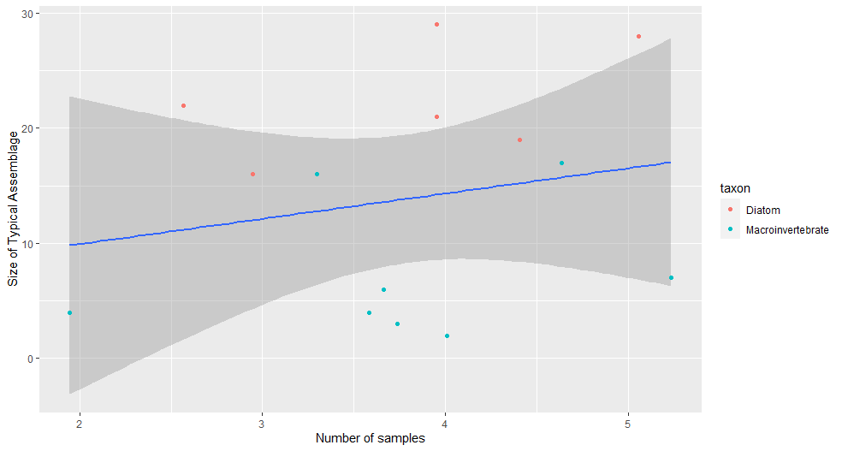

Figure 4: Regression of the size of typical assemblages against the number of sampling locations. Gray shaped area shows the 95% confidence interval for the regression line. The color of the dots indicates the taxon group.

The number of sampled communities does not differ strongly between taxa (Table 6). Most importantly, the number of macroinvertebrate samples for one river type is lower than that of diatom samples in RT11 and RT15 while the other one is higher. Thus, the overall difference in richness can not be explained by the number of sampled communities. The mean number of taxa in diatom communities was lower than in macroinvertebrate communities. The total number of taxa was also lower for diatoms than for invertebrates. This might partly also be due to the extensive harmonization efforts that summarized some diatom species in larger complexes. However, it also highlights that there is less variation between sites within river types, which is conductive to larger TA. Strong turnover between sites within one RT or season leads to low average fidelity (B value) and consequently to few taxa that are included in the typical assemblages.

The methodology we employed is an implicit test of the fit of the river typology to our data. If the communities would vary independently of the typology, TAs would include few or no taxa.

Table 6: Several summary statistics of the sampling locations used to delineate seasonal typical assemblages

|  |  |  |  |  |  |  |  |  |
| --- | --- | --- | --- | --- | --- | --- | --- | --- |
| Class | River Type | Number of samples | Mean Richness | Medium Richness | Standard deviation | | Total number of taxa | Samples per season |
| Invertebrates | RT10 + 11 | 385 | 32.7 | 32.0 | | 11.7 | 257 | 55/188/103/39 |
| Invertebrates | RT 15 + 16 | 112 | 22.9 | 23.0 | | 9.3 | 113 | 7/42/27/36 |
| Diatom | RT 11 | 265 | 23.3 | 22.5 | | 7.1 | 140 | 0/157/52/13 |
| Diatom | RT 15 | 230 | 17.1 | 16.0 | | 6.5 | 99 | 0/82/19/52 |

# Seasonal typical assemblages

The two following figures (Figure 5 and Figure 6) show the typical assemblages and their connections

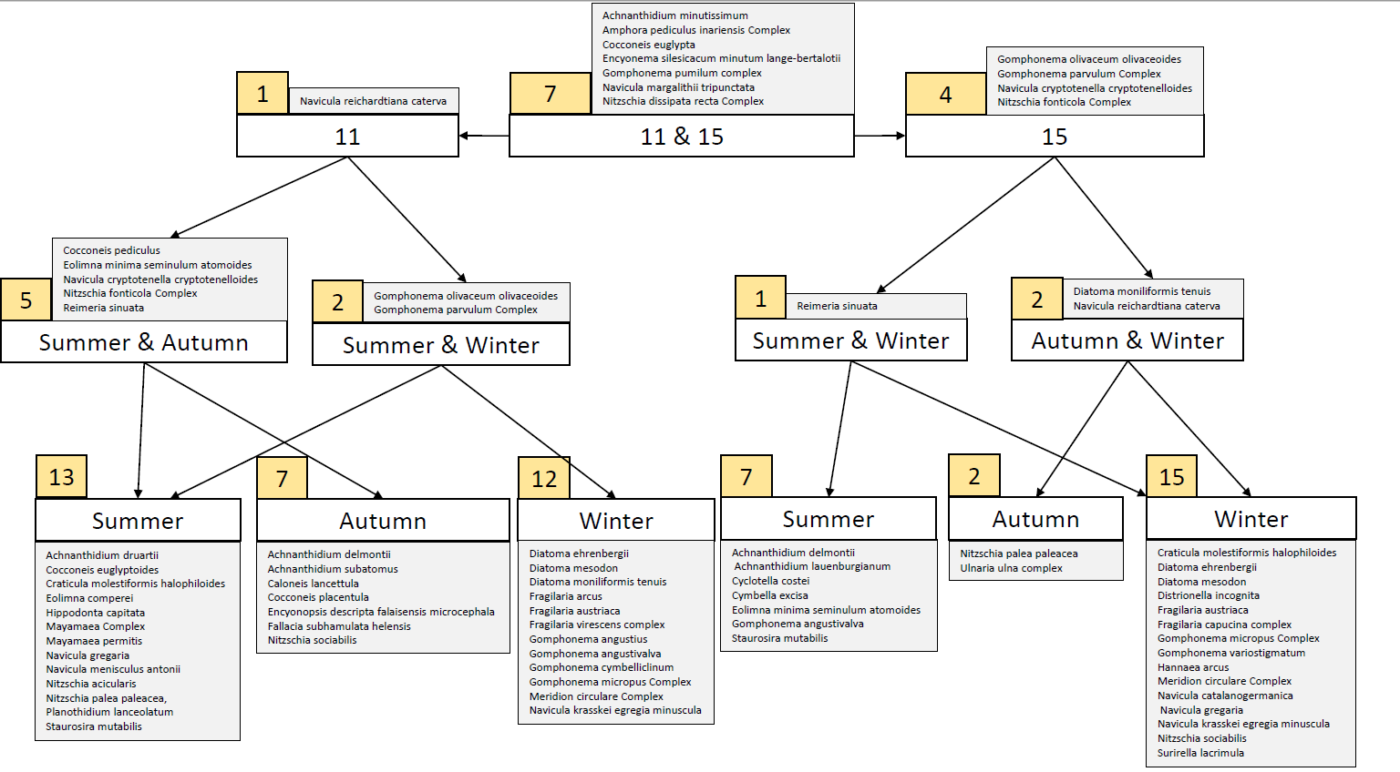

Figure 5: Seasonal typical diatom assemblages (sTA). The figure can be read as follows: The sTA for River Type (RT) 15 autumn consists of all taxa that are present in all sTAs of RT11 and RT15 (grey box above 11 & 15), taxa that are present in all sTAs of RT15 (Gomphonema olivaceum olivaceoides, Gomphonema parvulum Complex, Navicula cryptotenella cryptotenelloides, Nitzschia fonticola Complex), all taxa that are present in autumn and winter sTAs (Diatoma moniliformis tenuis and Navicula reichardtiana caterva) and taxa that are only present in the autumn sTA (Nitzschia palea paleacea and Ulnaria ulna Compex). The numbers in the yellow boxes show the number of taxa that are associated with a knot.

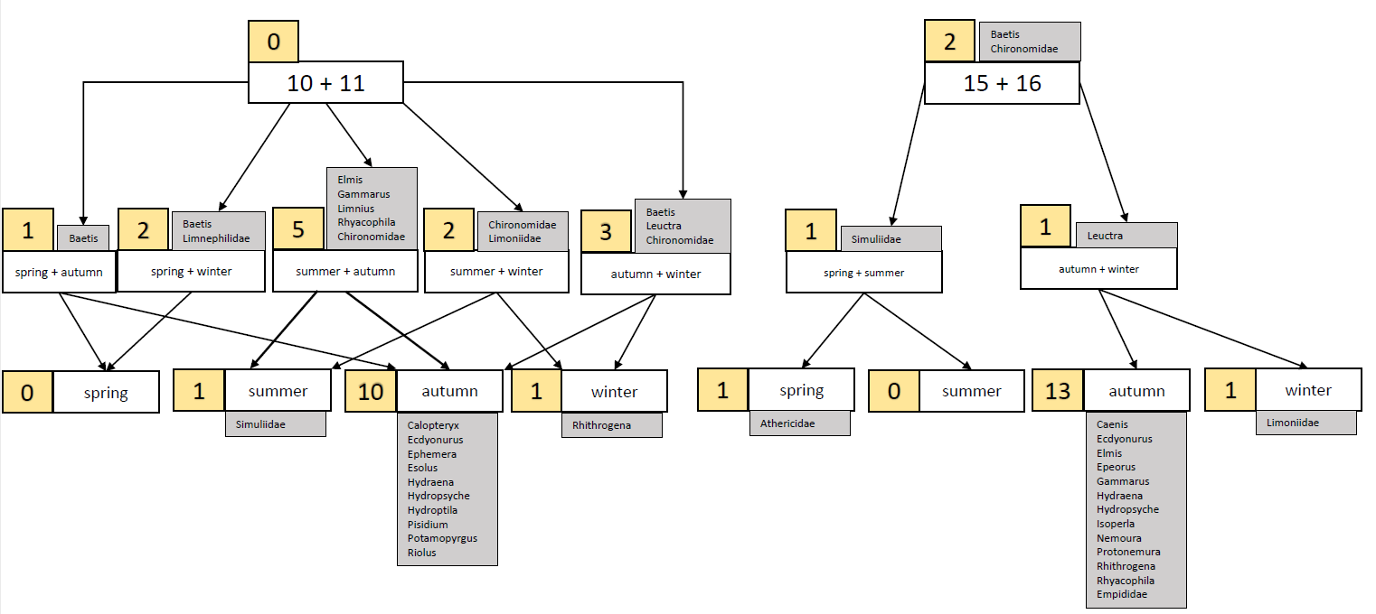

Figure 6: Seasonal typical macroinvertebrate assemblages (sTA). The figure can be read as follows: The sTA for RT10+11 winter consists of all taxa that are present in all RT10+11 sTAs (none), all taxa that are present in spring and winter (Baetis and Limnephilidae), taxa that are present in summer and winter (Chironomidae and Limoniidae), taxa that are present in autumn and winter (Baetis, Leuctra, Chironomidae) and taxa that are only present in winter (Rhithrogena). The numbers in the yellow boxes show the number of taxa that are associated with a knot.